

**UNIVERSITY INSTITUTE OF ENGINEERING**

**Department of Computer Science & Engineering**

**Subject Name:** Competitive Coding

**Subject Code:** 20CSP-314

**Submitted to: Submitted by:**

Er. Mamta Punia Name: Sahil Kaundal

UID: 21BCS8197

Section: 616

Group: A

**INDEX**

| **Ex. No** | **List of Experiments** | **Conduct (MM: 12)** | **Viva**  **(MM: 10)** | **Record (MM: 8)** | **Total**  **(MM: 30)** | **Remarks/Signature** |
| --- | --- | --- | --- | --- | --- | --- |
| 1 | To demonstrate the concept of Array. |  |  |  |  |  |
| 2 | To demonstrate the concept of Stack and Queue. |  |  |  |  |  |
| 3 | To demonstrate the concept of Linked List. |  |  |  |  |  |
| 4 | Sorting and Searching: Implement the concept of Searching and Sorting techniques. |  |  |  |  |  |
| 5 | To implement the concept of Graphs. |  |  |  |  |  |
| 6. | To demonstrate the concept of Tree Data Structure |  |  |  |  |  |
| 7. | To Demonstrate the concept of String Data Structure |  |  |  |  |  |
|  |  |  |  |  |  |  |
|  |  |  |  |  |  |  |

**Experiment 7.1**

**Student Name:** Sahil Kaundal **UID:** 21BCS8197

**Branch:** BE CSE (Lateral Entry) **Section/Group:** 616/A

**Semester:** 5th **Date of Performance:** 28/10/2022

**Subject Name:** CC Lab **Subject Code:** 20CSP-314

1. **Aim/Overview of the practical:**

To Demonstrate the concept of String Data Structure

A numeric string, , is beautiful if it can be split into a sequence of two or more positive integers, , satisfying the following conditions:

<https://www.hackerrank.com/challenges/separate-the-numbers/problem?isFullScreen=true>

1. **Apparatus / Simulator Used:**

* Windows 7 or above
* Google Chrome

1. **Objective:**
   * To understand the concept of String Data Structure.
   * To implement the concept of String Data Structure.
   * To learn different approaches used to separate the numbers.

**4. Code:**

#pragma comment(linker, "/STACK:1000000000")

#include <cstdio>

#include <iostream>

#include <ctime>

#include <string>

#include <vector>

#include <cmath>

#include <algorithm>

#include <cstring>

#include <set>

#include <cstdlib>

#include <ctime>

#include <cassert>

#include <bitset>

#include <fstream>

#include <deque>

#include <stack>

#include <climits>

#include <string>

#include <queue>

#include <memory.h>

#include <map>

#include <unordered_map>

#define ll long long

#define ld double

#define pii pair <ll, ll>

#define mp make_pair

using namespace std;

int main() {

int q;

cin >> q;

while (q--) {

string s;

cin >> s;

if (s[0] == '0') {

cout << "NO\n";

continue;

}

ll now = 0;

bool st = false;

for (int i = 0; i < (int)s.size(); i++) {

now *= 10;

now += s[i] - '0';

ll res = 0;

if (s[i + 1] == '0') {

continue;

}

int cnt = 1;

for (int j = i + 1; j < (int)s.size(); j++) {

res *= 10;

res += s[j] - '0';

if (res == now + cnt) {

if (j + 1 == (int)s.size()) {

st = true;

break;

}

if (s[j + 1] == '0') {

break;

}

res = 0;

cnt++;

}

}

if (st) {

break;

}

}

if (st) {

cout << "YES " << now << endl;

} else {

cout << "NO\n";

}

}

return 0;

}

**5. Result/Output/Writing Summary:**

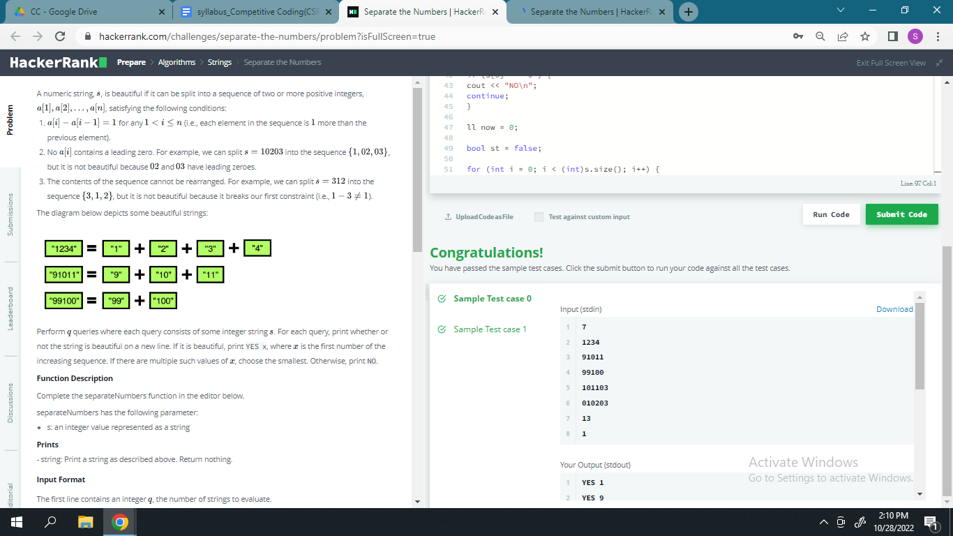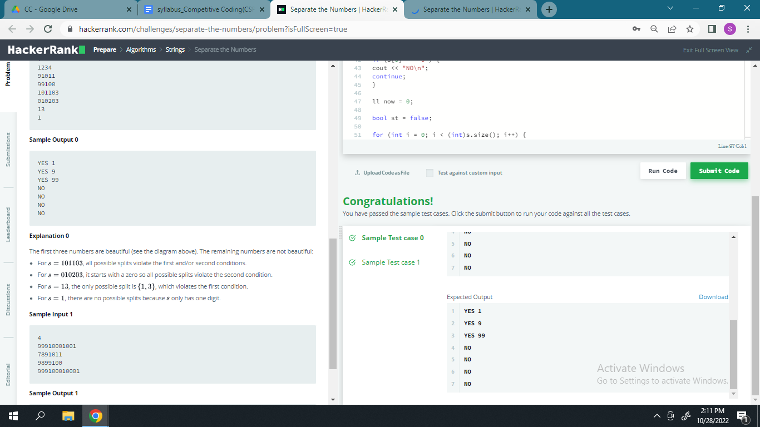

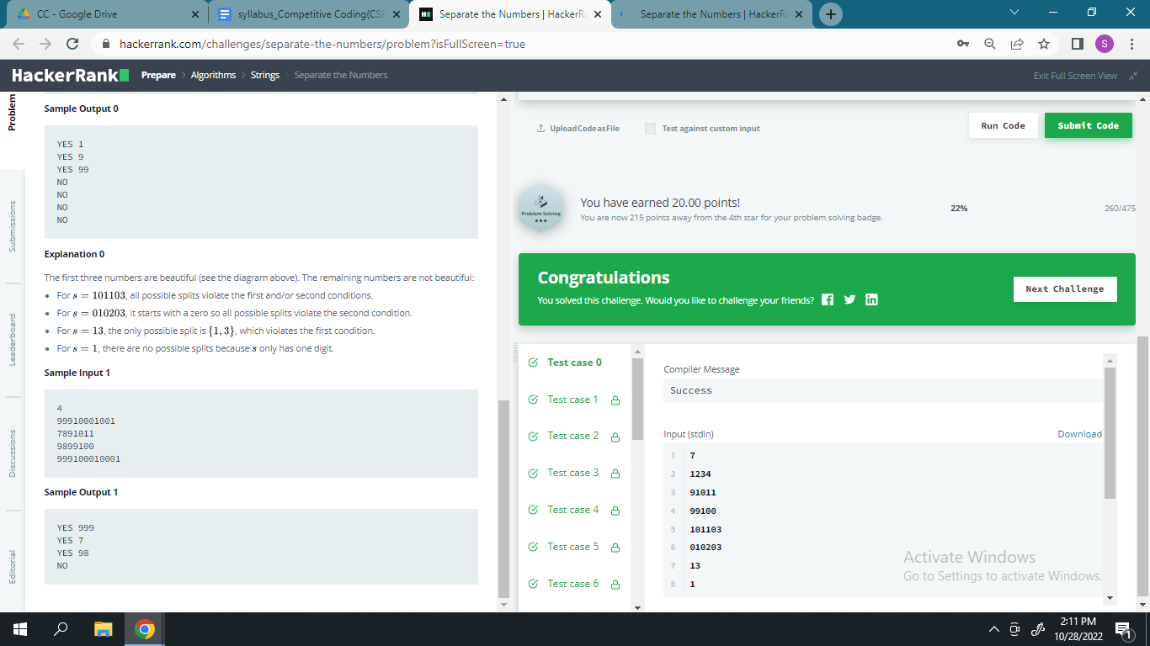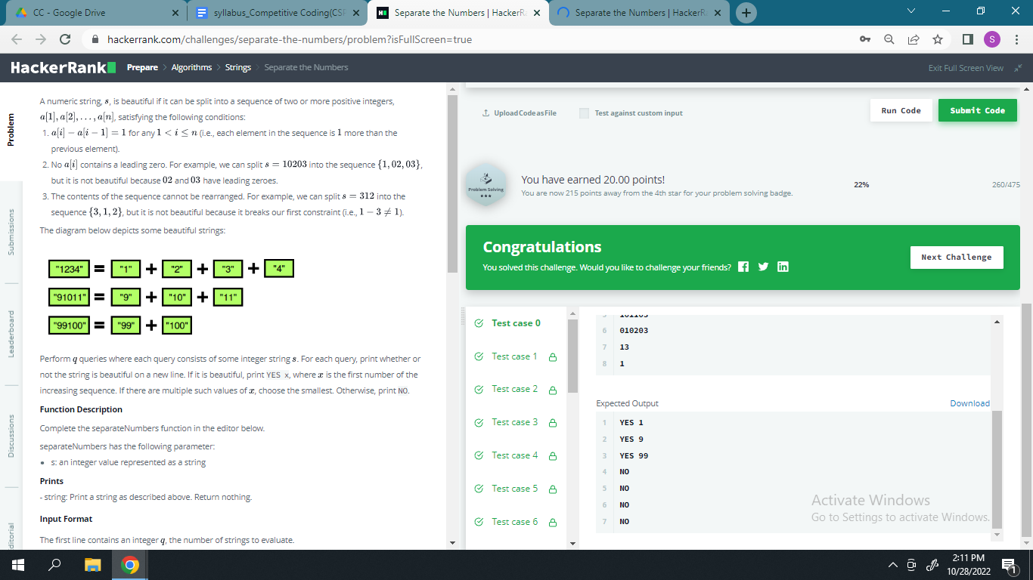

**Experiment 7.2**

1. **Aim/Overview of the practical:**

To Demonstrate the concept of String Data Structure

A pangram is a string that contains every letter of the alphabet. Given a sentence determine whether it is a pangram in the English alphabet. Ignore case. Return either pangram or not pangram as appropriate.

[**https://www.hackerrank.com/challenges/pangrams/problem?isFullScreen=true**](https://www.hackerrank.com/challenges/pangrams/problem?isFullScreen=true)

1. **Apparatus / Simulator Used:**

* Windows 7 or above
* Google Chrome

1. **Objective:**

* To understand the concept of String Data Structure.
* To implement the concept of String Data Structure.
* To learn different approaches used to separate the numbers.

1. **Code:**

#include <bits/stdc++.h>

using namespace std;

int main()

{

    string a; getline(cin, a);map <char,int> he;

    for (int g=0;g<a.length(); g++)

    {

        if (a[g]>='A' && a[g]<='Z')

        {

            a[g]=char(a[g]-'A'+'a');

            he[a[g]]++;

        }

        if (a[g]>='a' && a[g]<='z')

        {

            he[a[g]]++;

        }

    }

    for (int g=0; g<26; g++)

    {

        if (!he[char('a'+g)])

        {

            cout << "not pangram"; return 0;

        }

    }cout << "pangram";

    return 0;

}

1. **Result/Output/Writing Summary:**

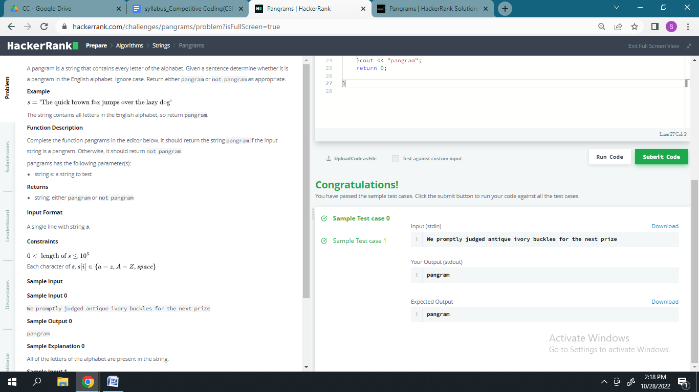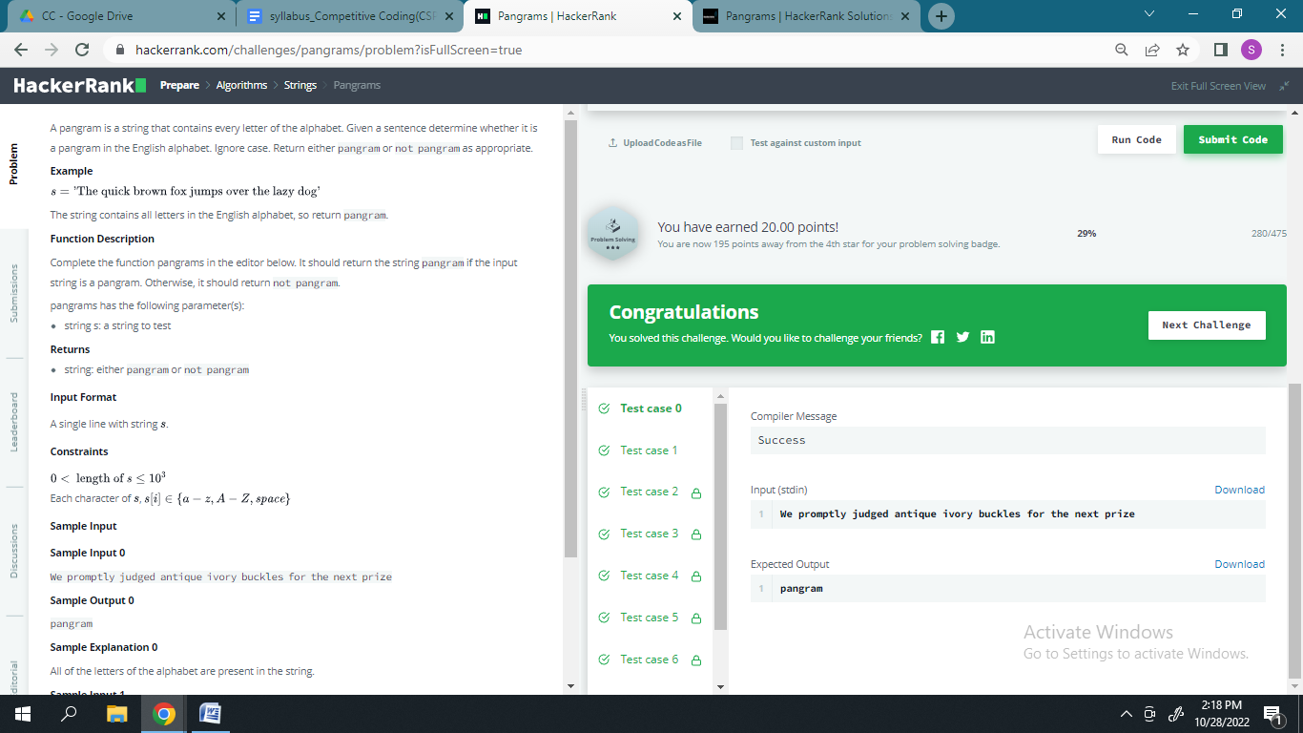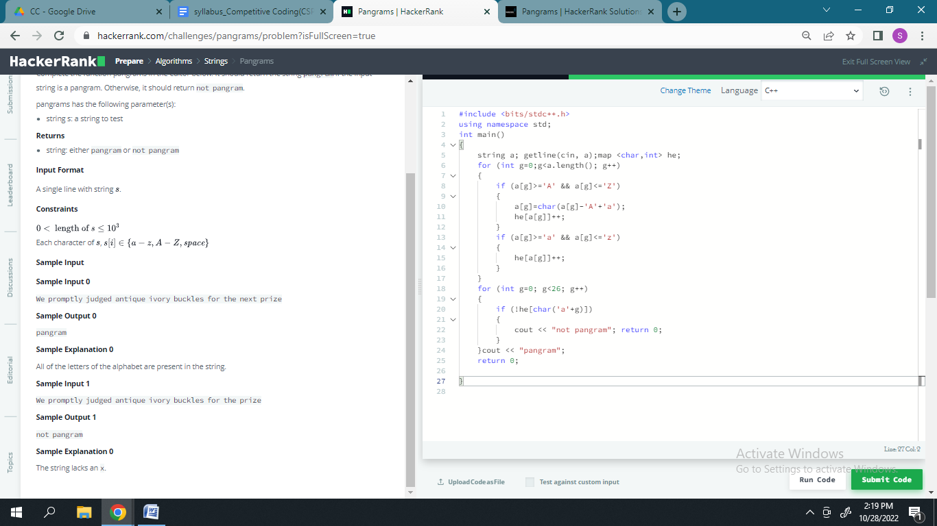

**Learning outcomes (What I have learnt):**

* Learned about the concept of String Data Structure.
* Learned about implementing the concept of String Data Structure.
* Learned different approaches used to separate the numbers**.**

**Evaluation Grid (To be created as per the SOP and Assessment guidelines by the faculty):**

| Sr. No. | Parameters | Marks Obtained | Maximum Marks |
| --- | --- | --- | --- |
| 1. |  |  |  |
| 2. |  |  |  |
| 3. |  |  |  |
|  |  |  |  |